Enzyme Practice Sheet Key

- (4 points) Label the boxes as the: enzyme catalyzed reaction or non-enzyme catalyzed reaction. Explain what is occurring and the effect on the reaction

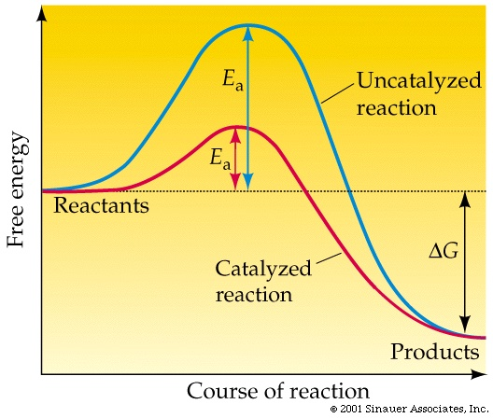

- Classify the enzymes that catalyze the reactions below as being one of the following (Oxidoreductase, hydrolase, isomerase, ligase, lyase, transferase,)

- Differentiate between lock and key model and induced fit model of enzyme action?

- Draw a cartoon diagram to illustrate an enzyme that binds to a substrate (represented by a triangle) only in the presence of an activating factor (represented by a circle). Your diagram should have an illustration for the enzyme alone, the substrate NOT binding to the enzyme alone, the enzyme with the activating factor, and the enzyme, activating factor, and substrate combined.

- If an enzyme has a maximum activity at 40°C, would the activity be most reduced at 30°C or at 50°C? Explain.

- Explain how different factors can affect enzyme reaction rate (pH, temperature, and substrate)

- Why does increasing the substrate concentration reverse the inhibition by a competitive inhibitor?

- Describe the difference between reversible and irreversible inhibition, and between competitive and non-competitive inhibition

- Illustrate and label the interactions between this hypothetical model of a substrate molecule bound in the active site of an enzyme

- Enzyme terminology fill in the correct word for the definition

___________________: active site in an enzyme has a fixed, rigid shape. Only substrates with a complementary geometry can fit.
___________________: active site in an enzyme can undergo small changes in shape in order to accommodate a substrate

___________________: goes on and off, allowing the enzyme to regain activity when the inhibitor leaves

___________________: destroys enzyme activity, usually by bonding with side-chain groups in the active site
___________________: competition between an inhibitor and substrate of similar structure for the active site of the enzyme
___________________: inhibitor binds to enzyme at a location other than the active site and deactivates the enzyme.
___________________are inorganic species or at least non-protein compounds that aid enzyme function by increasing the rate of catalysis.

___________________ are non-protein organic molecules that bind loosely to an enzyme that is required for a protein's biological activity to happen.

___________________- the compound on which the enzyme works

___________________- the specific portion of the enzyme to which the substrate binds during reaction.

___________________- any process that makes an inactive enzyme active.

___________________- Inactive form of an enzyme.

